**Rossmoyne Senior High School Physics Unit 3 and 4 2021**

**Period Zero Test 1: Gravity and Motion**

**Name: __________________________________ Score: _________ /42**

**Time:** 45 min + 5 min reading

**Materials Provided:** This Question/Answer Booklet and the Formulae and Data Booklet

**Instructions:** When calculating numerical answers, show your working or reasoning clearly and include appropriate units. Give final answers to **three** significant figures. When estimating numerical answers, give final answers to a maximum of **two** significant figures.

1. The diagram below shows a 1.50 kg box sliding down a ramp at a constant velocity

25.00

* 1. Draw a **labelled** vector diagram below, showing the relationship between the forces acting on the box. [3 marks]

N

**All** 3 vectors, in correct shape 1

**All** arrows in correct direction 1

**All** labels 1

W

Friction

* 1. Calculate the magnitude of the reaction force applied to the box by the ramp.

[2 marks]

1

1

* 1. Calculate the magnitude of friction acting on the box. [2 marks]

$Frict=mgsinθ$ 1

$N=1.50×9.8×sin25=6.21 N$ 1

1. A toy company claims their latest water gun can fire a stream of water at 2.80 m s-1. Brook holds this water gun angled 15.00 above the horizontal, such that the nozzle is 1.40 m above the flat ground. Ignoring the effects of air resistance:
   1. Find the horizontal range of the water stream from Brook’s water gun. [4 marks]

$u_{v}=2.80\sin{(15)}=0.7247 m s^{-1}$ (1)

Find time in air:

**OR**

(1-2)

(1)

* 1. Calculate the velocity of the water stream 0.200 s after it leaves the nozzle. Include the direction. [4 marks]

$u_{h}=2.80\cos\left(15\right)=2.705 m s^{-1}$ (may have been calculated in part a) (1)

(1)

(1)

(1)

* 1. Brook fires a second stream of water with the water gun now held perfectly horizontal, keeping the nozzle at the same height as before. Will this second water stream hit the ground with more, less or the same speed as the first stream? No calculation is required, but you must justify your choice. [4 marks]

The same. (1)

Both streams of water start with the same total energy (kinetic + potential) due to starting at the same speed and the same height. (1)

Upon reaching the ground, both streams have converted their potential energy into kinetic. Both streams hit the ground with the same kinetic energy, (1)

thus have the same speed. (1)

Max of two marks for incorrect choice (Lose two marks for "more/less speed" and the incorrect Physics, such as horizontal v remains constant between streams)

* 2 marks are for the logic of the student argument, as follow-through.

1. Proxima b is a planet orbiting our neighbour star, Alpha Centauri. Observations reveal Proxima b is 1.30 times more massive than our own planet and orbits 7.50 Gm from Alpha Centauri. Proxima b’s orbit around its sun lasts 11.2 Earth days.
   1. Calculate the mass of Alpha Centauri. [4 marks]

(1)

(1)

(1-2)

* 1. Calculate the acceleration of Proxima b as it orbits its sun. If you could not obtain an answer to part (a) you may use 2.60 × 1029 kg. [2 marks]

$a_{c}=g=\frac{GM}{r^{2}}$

$a_{c}=\frac{6.67*{10}^{-11}×2.666×{10}^{29}}{{\left(7.50×{10}^{9}\right)}^{2}}=0.316 m s^{-2}$ (1-2)

May also use a combination of $v=\frac{2πr}{T}$ and $a=\frac{v^{2}}{r}$

1. An ice skater performs a 3600 twirl in 0.800 s with arms extended (diagram A). A few seconds later she performs another twirl, with arms tucked in (diagram B), also in 0.800 s. A 3.00 × 10-6 kg ant is sitting on the back of her hand prior to each twirl.

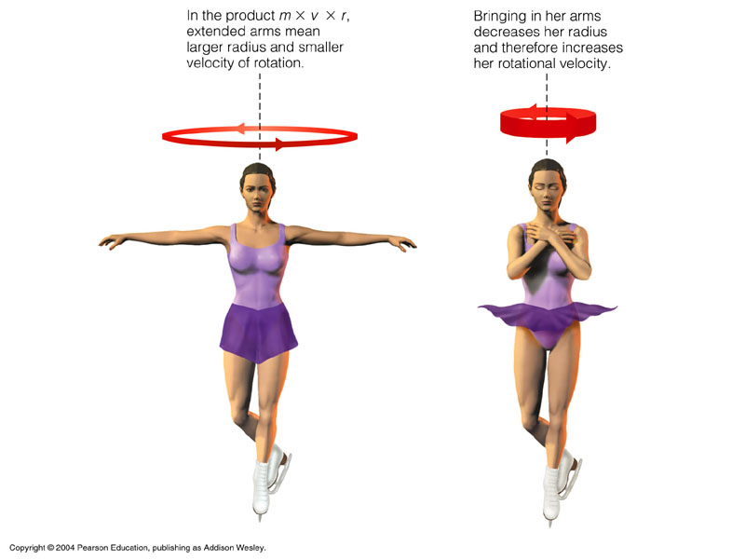

A

B

Estimate the centripetal force acting on the ant as the ice skater performs the twirl as shown in diagram A. Give your answer to an appropriate number of significant figures.

[5 marks]

$Estimate arm length ≈0.80 m$ (reasonable estimate between 0.50 and 1.20 m, 1)

$v=\frac{2πr}{T}=\frac{2π×0.80}{0.800}=6.28 m s^{-1}$ (1-2)

$F_{c}=\frac{mv^{2}}{r}=\frac{3.00×{10}^{-6}×{6.28}^{2}}{0.80}=1.5×{10}^{-4} N$ (1-2, must have 1-2 sig figs)

1. A ball rolls down a frictionless ramp and then completes a vertical loop, as shown in the diagram below.

$$h_{1}$$

$$h_{2}=0.450 m$$

By first calculating the minimum speed the ball requires at the top of the loop to guarantee it will complete the loop, find the minimum initial starting height, $h_{1}$, of the ball. [6 marks]

At the top of the loop, $F_{c}=W$

$\frac{mv^{2}}{r}=mg$ (1)

$v=\sqrt{rg}= \sqrt{\frac{0.450}{2}×9.8}=1.485 m s^{-1}$ (1-2)

$Energy at h_{1}=Energy at h_{2}$ (1 (any evidence of conserving energy)

$mgh_{1}=mgh_{2}+\frac{1}{2}mv^{2}$

$9.80×h_{1}=9.80×0.450+\frac{1}{2}{\left(1.485\right)}^{2}$

$h_{1}=0.563 m$ (1-2)

1. Two identical 2.00 cm wide spherical objects are positioned such that their closest points are 16.0 cm apart.
   1. Draw the gravitational field in the space surrounding the two masses. [3 marks]

Field lines contain arrows pointing towards masses (1)

Even distribution of lines between spheres, no crossing lines (1)

Field between masses is suitably curved and not on far sides (1)

* 1. Determine the mass of one of the spherical objects if the gravitational force acting on each of them is 3.60 × 10-18 N. [3 marks]

where $M=m$

$F=\frac{Gm^{2}}{r^{2}}$ (1)

$3.60×{10}^{-18}=\frac{6.67×{10}^{-11}×m^{2}}{{(0.16+0.02)}^{2}}$

$m=4.18×{10}^{-5} kg$ (1-2)

**End of Test**